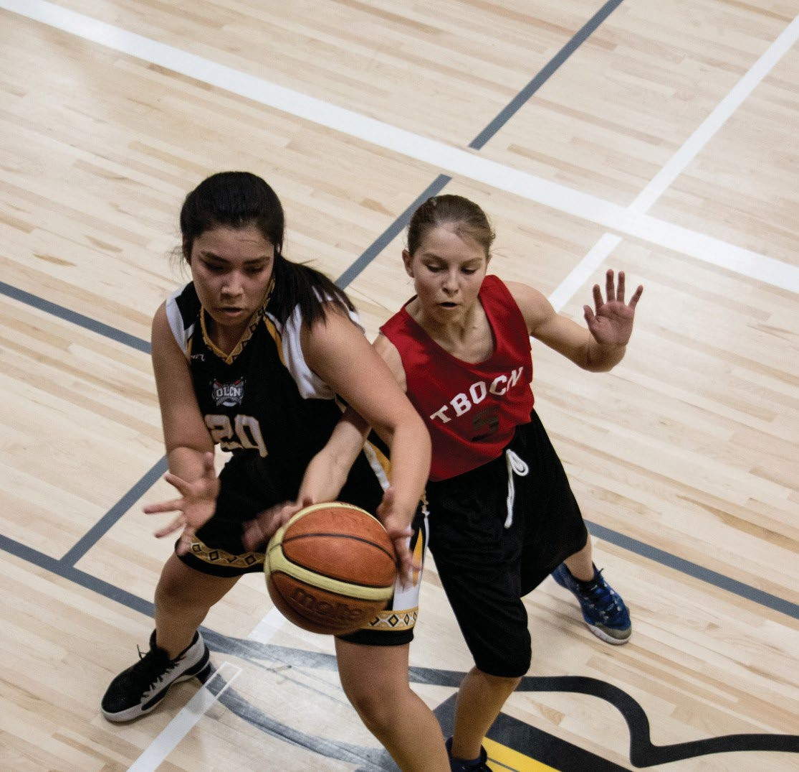


INDIGENOUS COMMUNITY SPORT DEVELOPMENT GRANT PROGRAM
GUIDELINES
AUGUST 2026

INDIGENOUS COMMUNITY SPORT DEVELOPMENT
GRANT PROGRAM GUIDELINES

- PURPOSE
To provide financial assistance to support new or the expansion (enhancement) of existing organized community sport programs for Indigenous children and youth in Saskatchewan.
Expansion refers specifically to the growth of an existing program in a way that introduces new opportunities for athlete participation. This may include:
- Enhanced equipment and resources.
- Increased access to qualified coaching and instruction.
- Expanded programming to additional age groups.
- Delivery of programming in new locations and communities.
- Opportunities for league play and competitive participation.

Expansion does not include general program enhancements such as increased
practice time, individual coach development, administrative improvements, etc. The focus
must be on launching new programs that are designed to be sustainable beyond
the grant period.

- DESIRED OUTCOMES
  - Increase the number of Indigenous children and youth participating in organized sport programs in Saskatchewan.
  - Enhance and sustain organized sport opportunities for First Nations and Métis children and youth through new and improved programs.
  - Reduce barriers and support equitable access to organized sport opportunities for Indigenous children and youth.
  - Strengthen collaboration between Indigenous communities, schools, and sport organizations to organize leagues, tournaments, competitions, and shared programming opportunities.

- SOURCE OF FUNDING

The Indigenous Community Sport Development Grant Program is jointly funded through Sport Canada’s Indigenous Participation Bilateral Agreement through the Province of Saskatchewan and the Sask Lotteries Trust Fund for Sport, Culture and Recreation (Trust Fund). This grant is administered through Sask Sport and the Sport, Culture, and Recreation Districts.

For more information regarding the Indigenous Participation Bilateral Agreement, please see https://www.sasksport.ca/programs-services/general-participation-and-indigenous-bilateral-agreement/
- ELIGIBILITY
The following organizations are eligible to apply for the grant:
- Provincial Sport Organizations (PSOs) who are on the Eligibility List of the Trust Fund.
- Tribal Councils, First Nations communities, and municipalities provided endorsement is received from a Bonded Authorized Officer (Ex. Chief, Councilor, Mayor).
- Organizations that provide services with First Nations and Métis people and are registered under the Saskatchewan Non-Profit Corporations Act (these organizations must have been incorporated and in existence for a minimum of one year).
- Schools are eligible to apply, provided the application is submitted by an authorized school representative (e.g., Principal, Vice-Principal, Superintendent, or other designated administrator).
- Ineligible communities or organizations may partner with eligible communities/organizations to apply for support and deliver activities that meet the objectives of the program.
Individuals are ineligible to apply.

- AVAILABLE FUNDING

Approved amounts may vary depending upon the number of applications received and the level of funding available. Funding is subject to the sustainability of funding levels from the Trust Fund.

Type of Initiative | Single Initiative | Single Initiative - Multiple Communities | Multiple Initiatives -  One Community
Application(s) Needed | Single application, with one letter of support from the community. | Single application, with one letter of support from each community | One application for each initiative, with one letter of support from the community.
Minimum Amount of Available Funding | $1,000 per year | $1,000 per community | $1,000 per initiative per year
Maximum Amount of Available Funding | $5,000 per year | $5,000 per community, to a maximum of $25,000 per year | $5,000 per initiative per year to a maximum of $25,000 per year
Example | A community applies for upgraded equipment for their existing soccer program. | Three communities partner together to run a new football program. Together, they apply for their maximum of $15,000 ($5,000 per community). | One community applies for a new soccer, softball, and volleyball program. Each application is seeking the maximum $5,000 for each program.
Years of Available Funding | Up to three consecutive years per community initiative. After which, the initiative is considered ineligible.

REQUIREMENTS AND CONDITIONS
- This grant is made possible in part with Sask Lotteries, the main fundraiser for more the 12,000 sport, culture, and recreation groups in communities across Saskatchewan. Sask Lotteries must be promoted and recognized within all communications and promotions developed. The Sask Lotteries logo, brand guidelines, key messages and promotional materials are available at sasklotteries.ca/funding-recognition.
- This grant is intended for programs that primarily serve Indigenous children and youth (ages 5–18). Applicants must demonstrate that Indigenous participants are the primary beneficiaries of the program.
- Generally accepted sport activities are those recognized and/or sanctioned by the member organizations of Sask Sport. For a full listing of Sask Sport member organizations or their programs and services, please reference the Sask Sport website at sasksport.ca/about-us/membership.
- Eligible communities and organizations must be registered under the Saskatchewan Non-Profit Corporations Act and be in existence for a minimum of one year.
- Eligible communities or organizations must engage members of the community and work in collaboration to complete the application and budget.
- The applicant must provide one letter of support from a community leader that is not involved with the facilitation of the program (Ex. Chief, Councilor, school administrator, minor sport organization president, recreation board chair or community elected official, etc.).
- Applicants must have appropriate levels of participants' insurance covering projects, events and activities.
- It is encouraged that the sport program be led by a qualified coach or instructor. Coaches and Officials who are Indigenous can apply for funding under Indigenous Coaches and Officials Program (ICOP).
- Retroactive funding is not permitted. Therefore, applications must be submitted before the start date of the program.
- Approved programs and grant expenses must be within the grant period for which the grant is approved. Expenses that take place outside the grant period are not eligible for support. No carryover of unused grant funds is permitted.
- Grant payments will be withheld if the organization has any outstanding Trust Fund grant requirements. An example for communities is any outstanding Community Grant Program follow-up or reporting requirements. Examples for PSO’s are any outstanding Trust Fund grant requirements.
- Any changes to the original application must be submitted to Sask Sport or the District for review before any changes are made.
- Grants are approved with the understanding that funds are to be used for eligible purposes adhering to the Indigenous Community Sport Development Grant Guidelines. Any unused funds, or funds that are used for purposes that do not adhere to the grant guidelines will be required to be returned to Sask Sport.

7. APPLICATION PROCEDURES
The deadline for applications is April 30 and October 31 annually.

Applications submitted for the April 30 deadline are intended for programs starting on or after May 1, including those taking place in the fall or winter.

Applications submitted for the October 31 deadline are intended for programs starting on or after November 1, including those taking place in the spring or summer.

Application submissions in Saskatoon and Regina:

The application form can be found on the Sask Sport website at Indigenous Community Sport Development Grant Program - Sask Sport.

Application submissions located within the Sport, Culture, Recreation Districts:

The application form can be found on the district’s website. The list of district contacts can be found at Sport, Culture and Recreation Districts - Sask Sport.

The application must include the following:

- Completed Indigenous Community Sport Development Grant Program Application Form.

- Letter of support from a community leader that is not involved with the facilitation of the program (Ex. Chief, Councilor, school administrator, minor sport organization president, recreation board chair or community elected official, etc.).

- ASSESSMENT PROCESS

Saskatoon and Regina:

- The Indigenous Sport Leadership Council is responsible for the grant review process in consultation with Sask Sport.

Communities located within the Sport, Culture, Recreation Districts:

- Each district has its own adjudicating committee who is responsible for the grant review process in consultation with Sask Sport.

- ELIGIBLE EXPENDITURES
  - Facility rental
  - Non-personal sport equipment that must remain the property of the community or organization (Ex. Uniforms, footballs, soccer balls, equipment for introductory sport camps).
  - In province travel for competitions, training opportunities and development camps. Gas receipts must be accompanied by a completed expense/mileage claim form.
  - Program related costs such as athlete sport registration fees, transportation and instruction/skills camps fees. This includes programming costs that lead into the Tony Cote Games as a program outcome, provided the primary purpose of the funding is program delivery and participant development, rather than Games-related expenses.
  - Food expenditures that relate directly to a sport program. Food purchases directly related to an activity are eligible to a limit of 10% of the total grant.
  - Elder honorariums.
  - Other expenses deemed appropriate through consultation with Sask Sport.

- INELIGIBLE EXPENDITURES
  - Salaries and benefits for individuals involved in organizing or coordinating community sport programs.
  - Direct expenses related to participation in the Tony Cote Games, including but not limited to registration fees, travel, accommodation, meals, team uniforms, and other event-specific costs.
  - Travel accommodation expenses, including hotel stays, short-term rentals, lodging, and other overnight accommodation costs.
  - Expenditures that are covered by other grant funding. Two different grant sources cannot be used to pay the same dollar expense, whether those grants come from Sask Sport, the Trust Fund or any other grant provider.
  - Capital expenditures – no support is available for construction, renovations, upgrading, maintenance or operating costs of facilities.
  - Non-program specific equipment (Ex. bleachers, sound system, electronic score board, etc.)
  - Alcoholic beverages
  - Cash prizes
  - Out of province travel
  - Debt repayment
  - Payment of money returns owed to Sask Sport.
  - Other expenses that Sask Sport or the Trust Fund may deem inappropriate.

PAYMENT PROCEDURES
Approved grants will be distributed in two installments:
  - 75% of the approved grant amount will be provided following application approval.
  - The remaining 25% of the approved grant amount will be released upon receipt and satisfactory review of the required follow-up reporting.
Applicants with outstanding requirements related to other Trust Fund grant programs may still apply and be approved for funding. However, grant payments will be withheld until all outstanding requirements have been completed and deemed satisfactory (Ex. an organization with outstanding follow-up or reporting requirements under the Community Grant Program may receive grant approval but will not receive funding until those requirements have been completed and deemed satisfactory).

FOLLOW-UP PROCEDURES

The follow-up deadline is 60 days following program completion.

Follow-up submissions for Saskatoon and Regina:

The follow-up form can be found on the Sask Sport website at Indigenous Community Sport Development Grant Program - Sask Sport.

Follow-up submissions for organizations within the Sport, Culture, Recreation Districts:

The follow-up form can be found on the District website. The list of district contacts can be found at Sport, Culture and Recreation Districts - Sask Sport.

The follow-up must include the following:

- Signed and completed Indigenous Community Sport Development Grant Program Follow-up form.

- Copy of the financial documentation to verify expenses. Financial documentation (Ex. receipts, paid invoices) to verify eligible expenditures can take various forms but must at a minimum:

    - Indicate name of recipient (person or business) of the funds
    - Describe goods or services provided for payment
    - Disclose the amount of the payment
    - Include the date that the goods/services were purchased (must be within the grant period)
    - Include third party verification (supplier logo on an invoice, signature of the recipient on an expense claim or in the rare case where there is no other backup documentation, a copy of the cheque, with the bank clearing stamp on the back)

NOTE: Legible copies of documents for financial accountability (Ex. receipts, cancelled cheques, paid invoices, expense claims, etc.) are acceptable. Original documents are not necessary for submission to Sask Sport or the Sport, Culture, and Recreation Districts, but should be maintained by the community or organization submitting the grant follow-up report.

OR

- General Ledger listing from the organization’s accounting system outlining the grant expenditures during the grant period. The document must be signed by two signing authorities from the organization. Their names and positions must be clearly printed alongside their signatures.

Recipients are required to submit all follow-up reporting requirements by the deadline outlined in the grant guidelines. Failure to submit required follow-up information may result in delays in grant payments and may affect the organization's eligibility to receive future Trust Fund grants.

SEND APPLICATIONS AND FOLLOW-UP SUBMISSIONS TO:

Paul Ayres, Sport Consultant
510 Cynthia Street, Saskatoon, SK S7L 7K7
payres@sasksport.ca
306.212.7899
OR
Local District Contact

