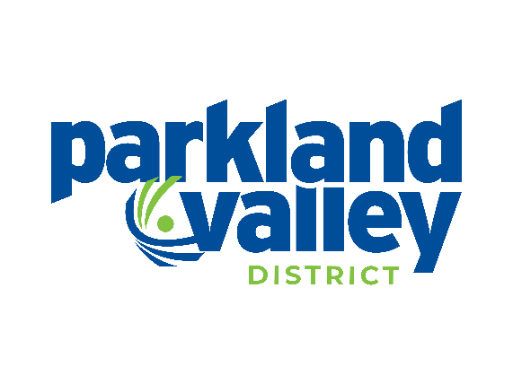
Parkland Valley Sport, Culture and Recreation District
Annual General Meeting
Wednesday, June 17, 2026
6:00PM

AGENDA
- Call to Order & Chairs Welcoming Remarks
Introduction of the Scrutineers & Registered Voting Delegate Numbers, second call for Nominations

- Approval of the Agenda
- Approval of Annual General Meeting Minutes – June 18, 2025
- Reports
- Annual Report (Chair & Executive Director)
- Financial Audit Report
- Tri-Global Report
- Final Call for Nominations

- New Business
- Bylaw Amendments
- Resolutions
- Other Business
- Election of Officers
  - Voting/Acclamation
- Introduction of the Board of Directors
- Adjourn

